**Sign-In page pdf's**

**Purpose:**

Make the Troubleshooting Guide, Quick Reference Guide, Privacy Statement, Hours of Access and Forgot Password Help .pdf’s, created and maintained by H.R. PeopleSoft Support and stored on the S: drive, available to employees for viewing via PeopleSoft HR Sign-In page.

**Process:**

* Using a WinSCP Windows Batch file (JOBDESCR)

- Write the S:drive .pdf files to the FTP site: ftp_hrdocs@cohvpwebapp2

* ITS DBA makes a one-time change to add the URLs.

**Maintenance:**

* H.R. PeopleSoft Support make changes to the .pdfs in S:\Human Resources\Common\ Sign-In Page (available in PeopleSoft Self-Service the next day)
* The above process is run nightly to remove the .pdf’s from the FTP site and copy the S:drive .pdf’s over.

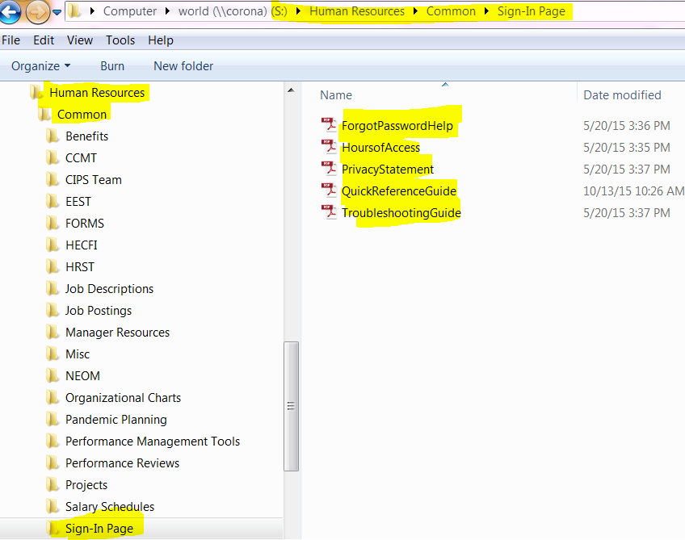

**FTP:** WinSCP Windows Batch nightly process will write the .pdf files to the ftp site: ftp_hrdocs@cohvpwebapp2

